Design Document

CLASSES

* **AlarmClock:**  Main class that listens to user requests and spread the task to the specific class below.
* **Alarm:**  Each instance indicates an alarm schedule.
* **FailSafeAlarm:**  Extends the Alarm class and includes a snooze counter. When fail safe is active, ActiveAlarm

will be initialized with a 3 minute parameter value.

* **WakeUpAlarm:** Extends the Alarm class and calls WakeUpChallenge to generate the UI to the algorithm

problem. Simultaneously, ActiveAlarm is called to generate the alarm sound and will listen to

the WakeUpAlarm if user answer’s question correctly.

* **SetAlarm:** Responsible for reading user input and storing it in the database.
* **TrackAlarm:** Compares current time to stored time in database (aka scheduled alarm). Alert
* **ActiveAlarm:** Turns on the alarm ring or vibrate. Called by Alarm, FailSafeAlarm and WakeUpAlarm.
* **WakeUpChallenge:** Randomly generate a math problem with respect to the difficulty level passed through the parameter.

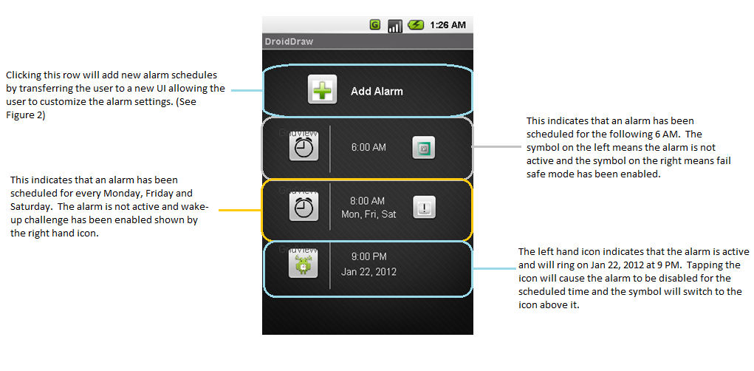

Figure 1: Main Menu of alarm app

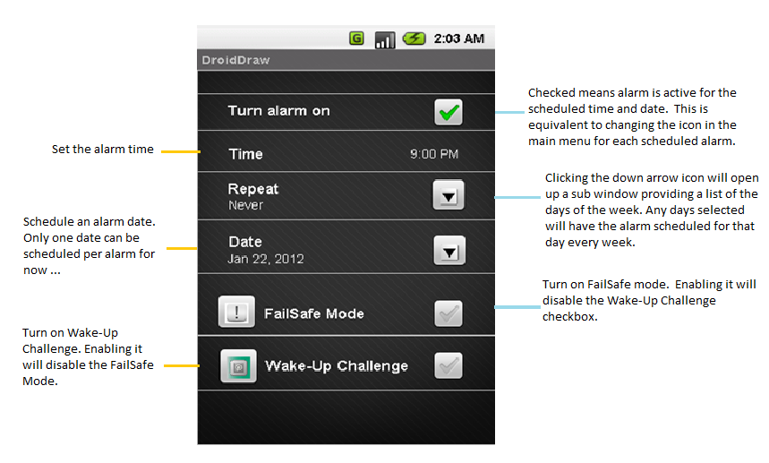

Figure 2: Alarm settings. User can access this screen either by adding an alarm

or modifying an existing alarm.

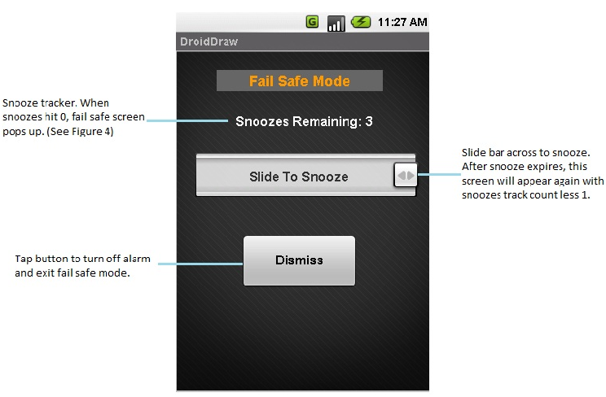

Figure 3: Alarm with Fail Safe Mode on.

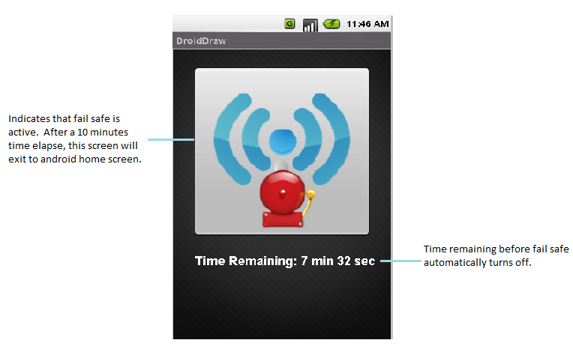

Figure 4: Fail Safe Active.